**Route Table:**

* Route table contains the rules to route the traffic in/out of the subnet/VPC
* Main Route table at VPC level
* Custom rouble table at subnet level
* Each route table contains default immutable local route for VPC
* If no custom route table is defined , then the subnet by default refers the main route table at VPC level
* We can modify the main route table

Example:

Consider the below image.

**Scenario 1: Connect two EC2 instances within VPC**

Diagram contains one VPC

* Two subnets in Availability Zone 1 and 2 respectively
* Each subnets has one EC2 instance A, B

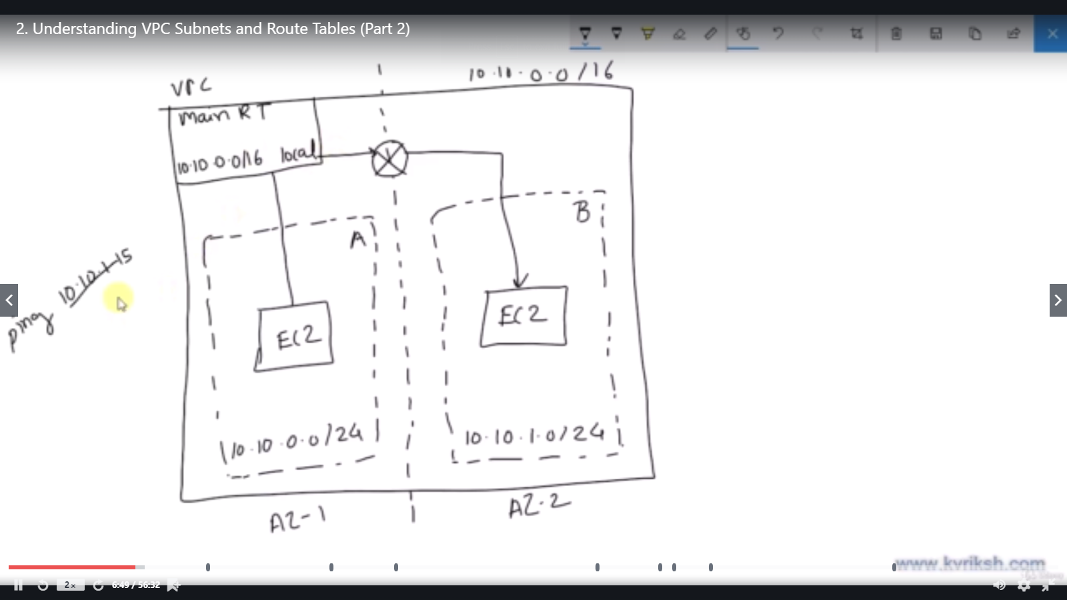

Now if you note,

* There is a main route table at VPC level .
* If the EC2 instance located in AZ-1 wants to connect with EC2 instance in AZ-2,
* It will check the main route table
* The main route table will have a default immutable entry for local routes.
* Hence the route table redirects the request to EC2 located in AZ2 with the help of the router.

**Scenario 2 : Connect anyone of the EC2 instances with Internet and try google.com**

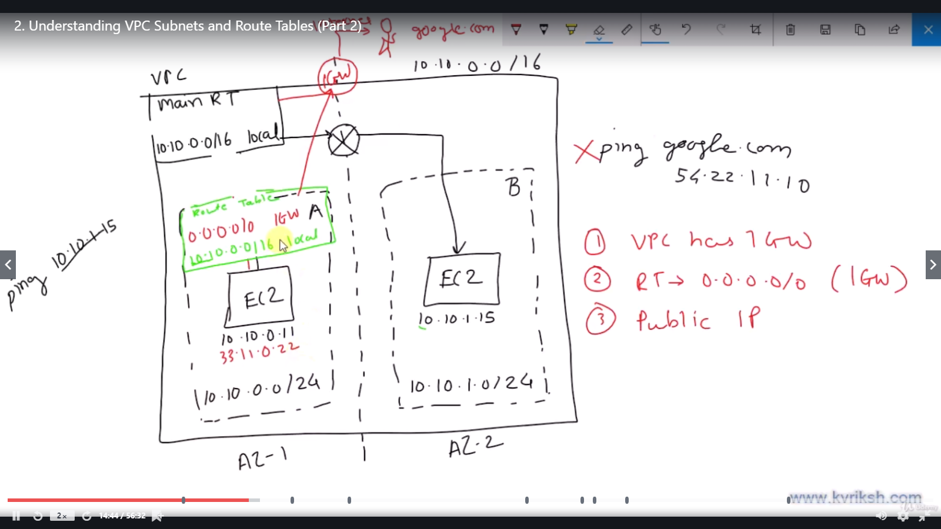

If we want to connect with outside VPC , we need below given three set up

**(i) Internet GateWay**

**(ii) Entry in routetable to reach/redirect to Internet Gateway**

**(iii) The EC2 instance should be having a public IP**

**Summary:**

**Route Table:**

* Route table contains the rules to route the traffic in/out of the subnet/VPC
* Main Route table at VPC level
* Custom rouble table at subnet level
* Each route table contains default immutable local route for VPC
* If no custom route table is defined , then the subnet by default refers the main route table at VPC level
* We can modify the main route table